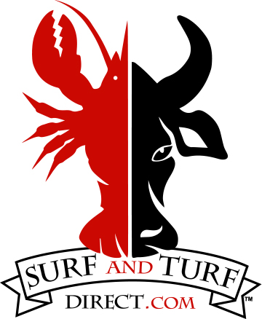

**Wild Caught - Sweet Pacific**

**Blue Shrimp SALE**

U15 EZ Peel 2 lb bag - $15.00

Shrimp Burgers 4 Count 1 lb box - $7.00

**Wild Caught - North American**

**Cold Water Lobster SALE**

**Tails Shell Off**

5 lb box ( $35.00/lb) - $175.00

Individual Tails 8oz+ - $40.00/lb

**Claws & Knuckles Shell Off**

6 lb box ( $25.00/lb) - $150.00

Individual Pack 8oz - $15.00

**Wild Caught Norway SALE**

Lobster Tail Bites2.5 lb bag $40.00

**Wild Caught – North Atlantic**

Dry Sea Scallops 1 lb bag - $32.00

Halibut 1.5 lb bag - $42.00

**Wild Caught – Nova Scotia**

**Cold Water Snow Crab SALE**

30 lb box ( $13.00/lb) - $390.00

Individual Clusters - $16.00/lb

**Cannon Valley Ranch**

**Akaushi Beef - MN Raised**

Tenderloins 7-9oz - $24.00 - $31.00

Boneless Ribeye 13-17oz – $39.00 - $51.00

NY Strip 10-13oz – $23.00 - $29.00

Top Sirloin 9-13oz – $15.00 - $22.00

T-Bone 1.38-1.52lb – $58.00 - $65.00

Denvers 5-7oz – $10.00 - $13.00

Hamburger 1lb - $10.00 each

Current Price List 10/25/2024

SurfAndTurfDirect.Com